Foundation subject assessment

At the heart of our ethos regarding the assessment of foundation subjects is the model below.
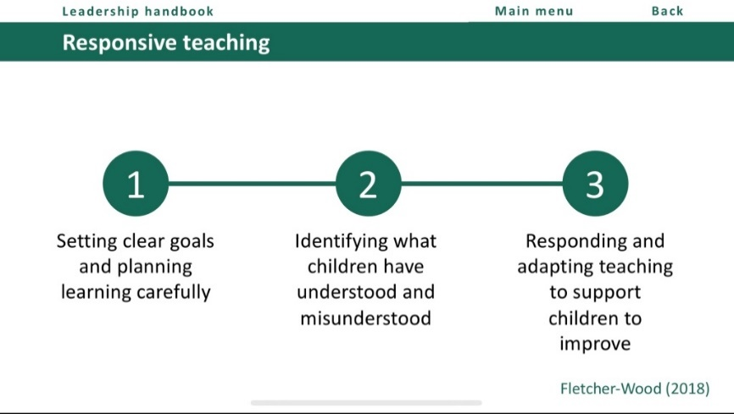

- Medium Term planning and subsequent lesson planning, which combines the substantive knowledge (including the progressive vocabulary) and the disciplinary knowledge (how a historian, geographer, scientist constructs their understanding of their subject)

- Formative feedback and assessment during the lesson through observation, questioning, discussion, low stakes quizzing and less commonly, written feedback in books

- Teachers adapt and amend their planning based on the AFL & feedback gained from above to endeavour to close the gaps/address misconceptions/further explain a concept/provide a different context in order for the pupils to improve. Having a focus through an enquiry question enables teachers to delve deeper into a topic, rather than rushing through coverage which enables time for this to happen

In order to be able to do this well, teachers need to know how what is taught in foundation subjects connects with the bigger picture. This is mapped in the MTP and through carefully planned enquiry questions (for history, geography & science). An example below highlights the components and composites of an art curriculum and this is what we are working towards.
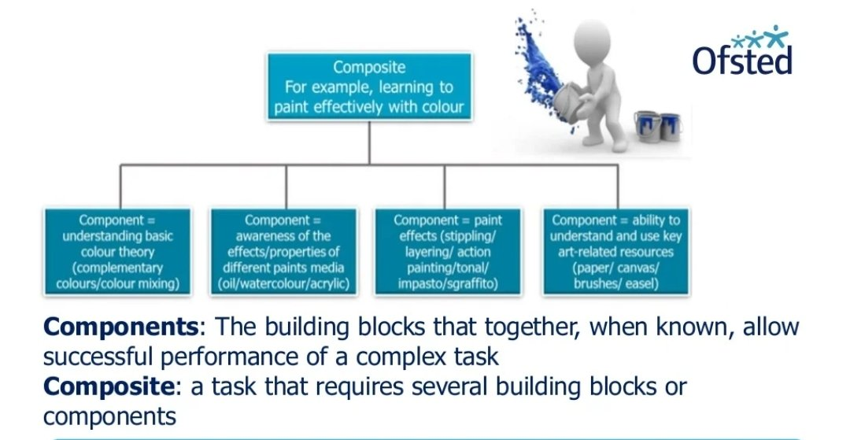

At the end of a topic, teachers complete a simple assessment based on the enquiry question which tracks pupils’ understanding. This enables subsequent teachers to see where any gaps are that need to be filled.

